**TASK 2**

**WINDOWS INSTALLATION**

**a) Installation of Windows**

**1. Identification of key stages in the installation**

We must make sure our machine satisfies the system requirements, obtain the installation media, make a bootable USB or DVD, have a working product key for activation, back up critical files, and, if desired, have an internet connection in order for Windows 10 Pro to install successfully. It is imperative to follow the installation guidelines supplied by Microsoft or the related documentation.

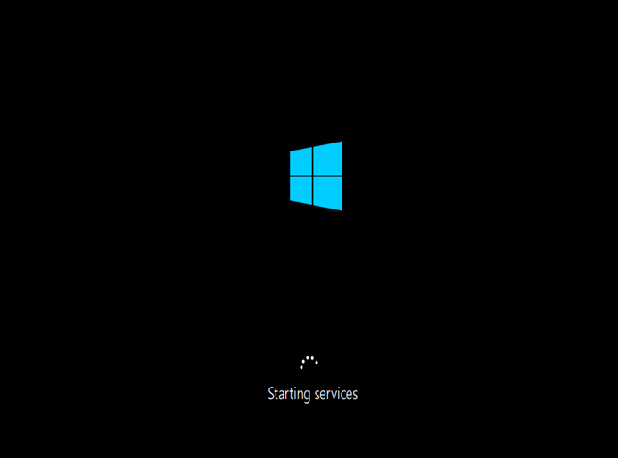

Firstly, boot the computer from the installation media, and a message to “Press any key to boot from the CD or DVD” appears. The Windows 10 logo then surfaces, and the Windows 10 installation procedure began.

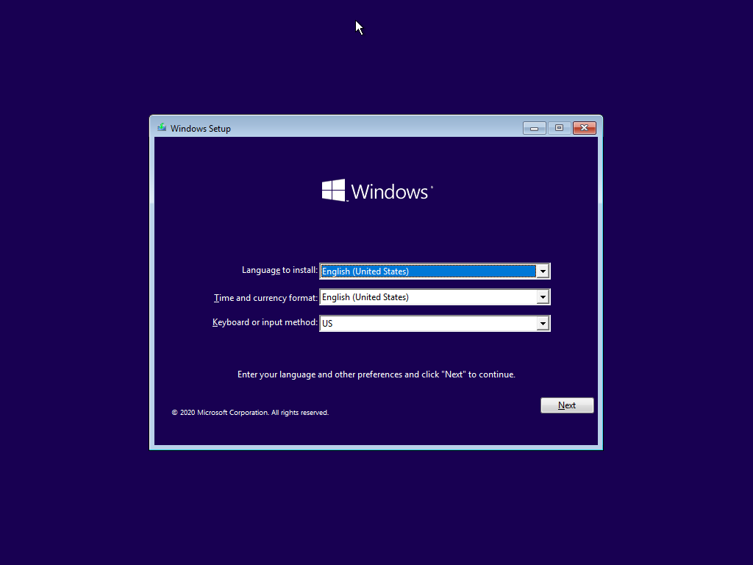

A short while later, the window setup from appeared. We have to select the keyboard layout, time and currency formats, and interface language. Once through those steps, press the “Next” button.

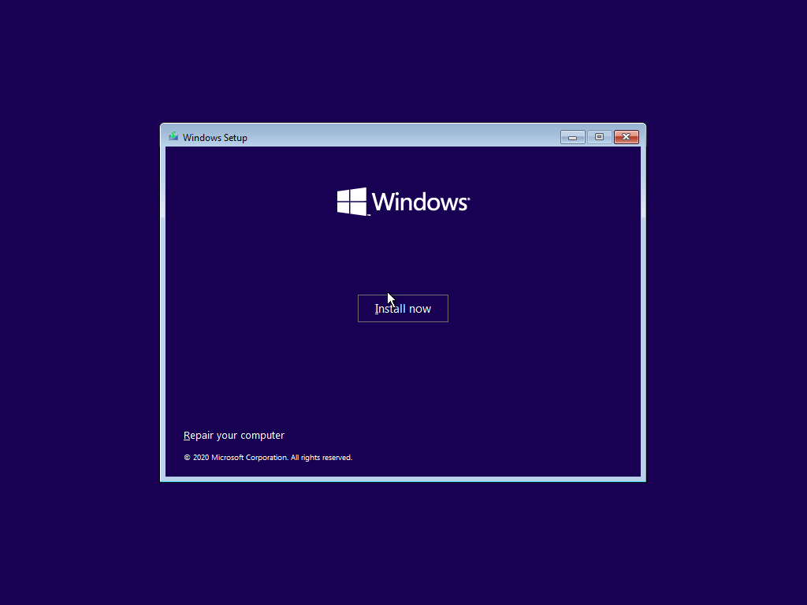

Users are then presented with two options: “Install now” and “Repair your computer”. Click the “Install now” button to start the Windows installation. The installation process will start as a result.

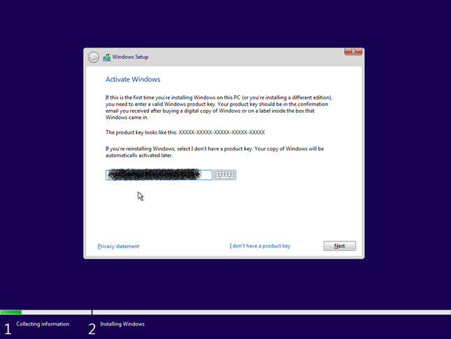

Entering the Windows 10 product key is the next step in the Windows activation process. But if you’re reinstalling Windows or don’t have a product key, just select “I don’t have a product key.” If you skip this step, Windows will launch in trial mode and need to be activated later. Once the product key has been entered, click “Next”.

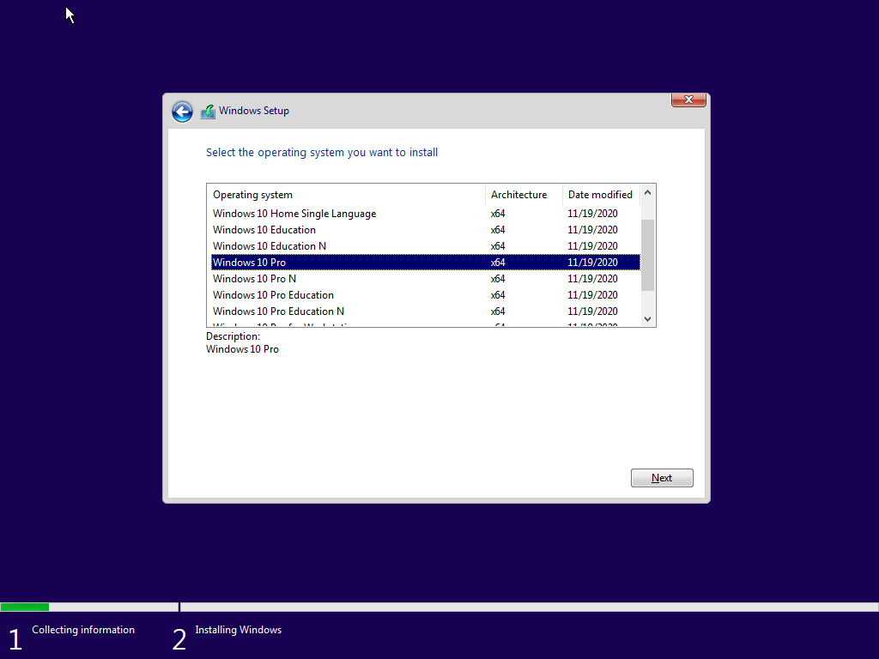

The next step is to select the Windows edition, which in this case is Windows 10 Pro. Click the “Next” button once it is complete.

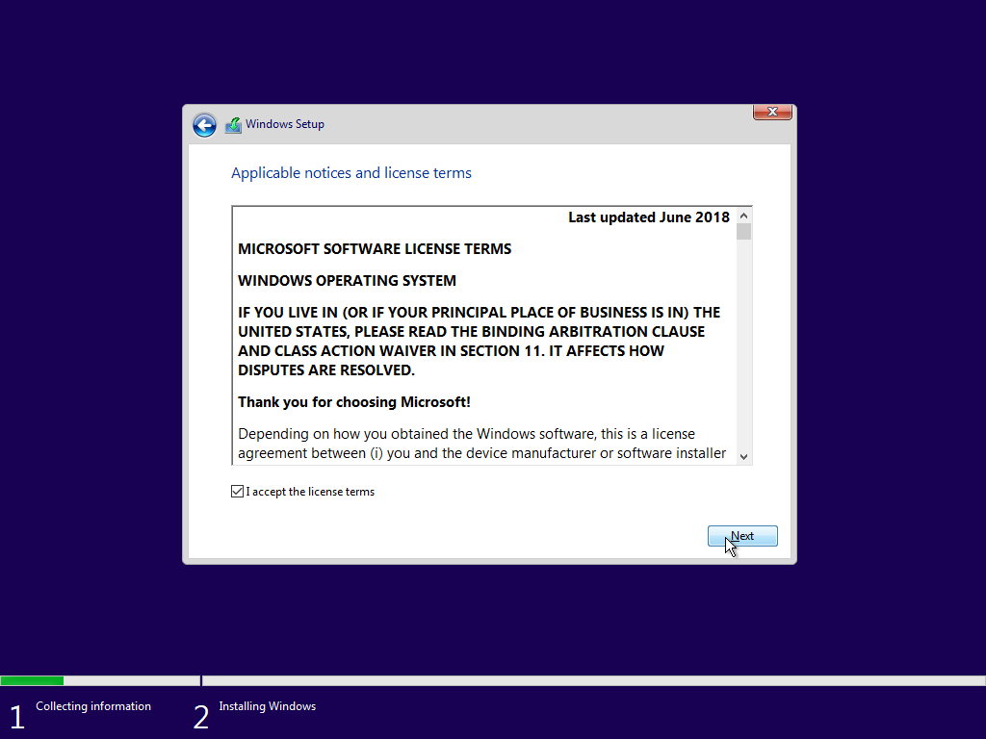

The End-User License Agreement, or EULA, contains license restrictions that must be accepted in order to continue. Once completed, press the “Next” button.

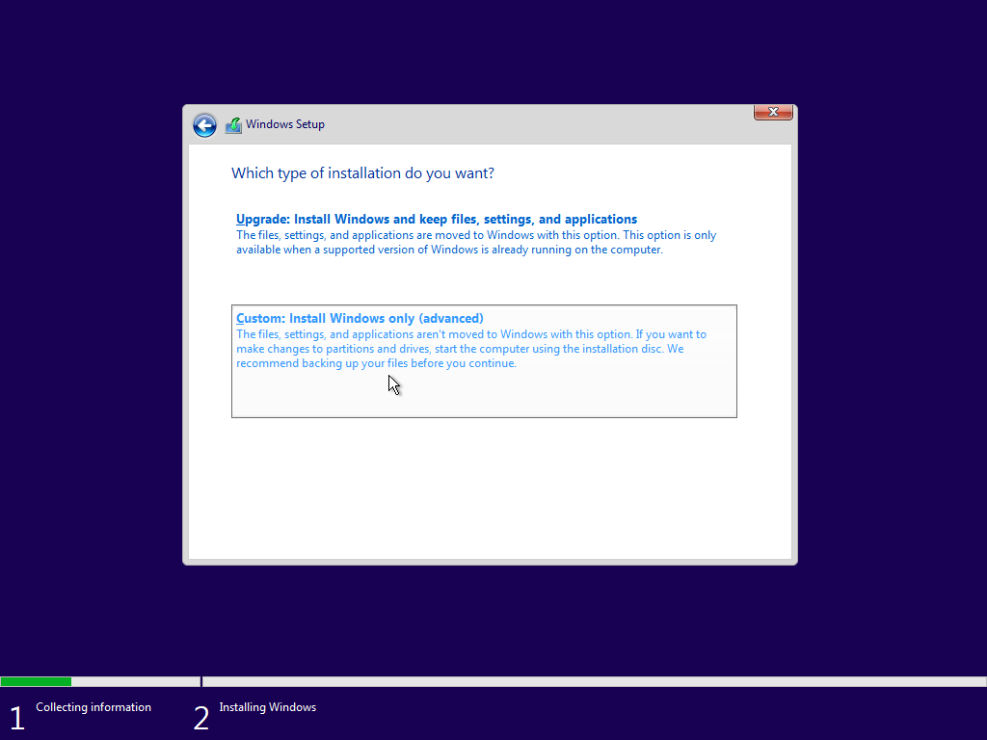

In this phase, you have to choose between the two installation types: “Upgrade” and “Custom”. Choosing the “Upgrade” option enables you to move to a newer version of Windows while keeping your files and applications. On the other hand, whether installing on a new drive or for a clean installation, the “Custom” option works well. Regarding a new device, the “Custom” option is chosen in the current case.

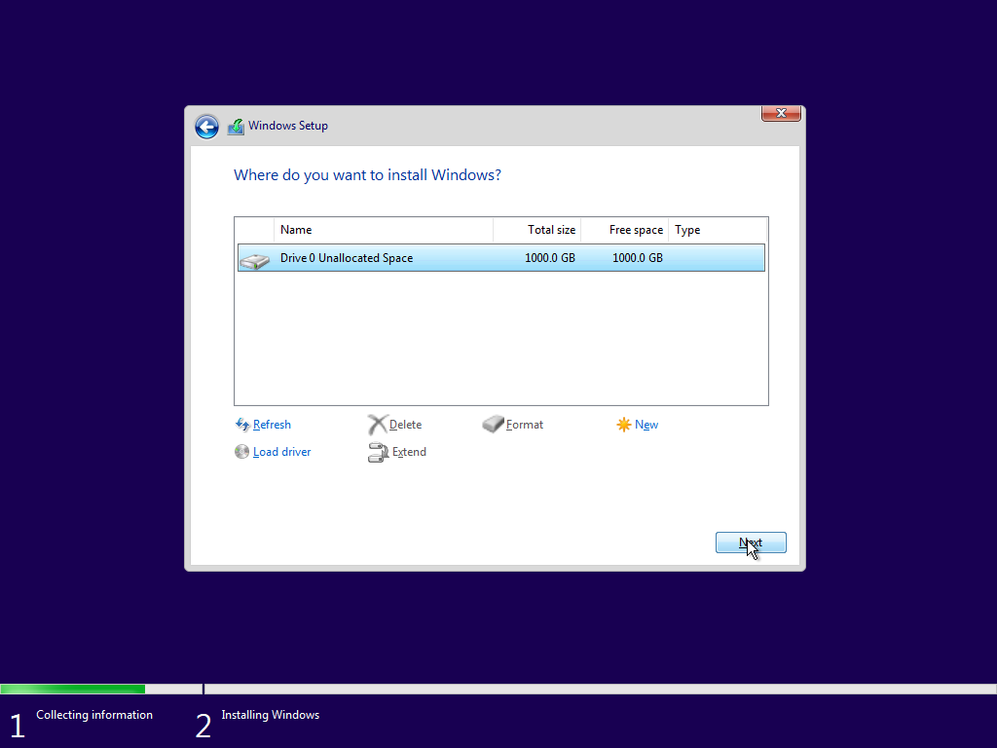

The time has arrived to choose the drive or installation partition on which the Windows files will be installed. During this stage, the current disk can be divided into smaller virtual disks, however larger disks are usually recommended. To carry out the installation procedure after choosing the preferred partition, click the "Next" button.

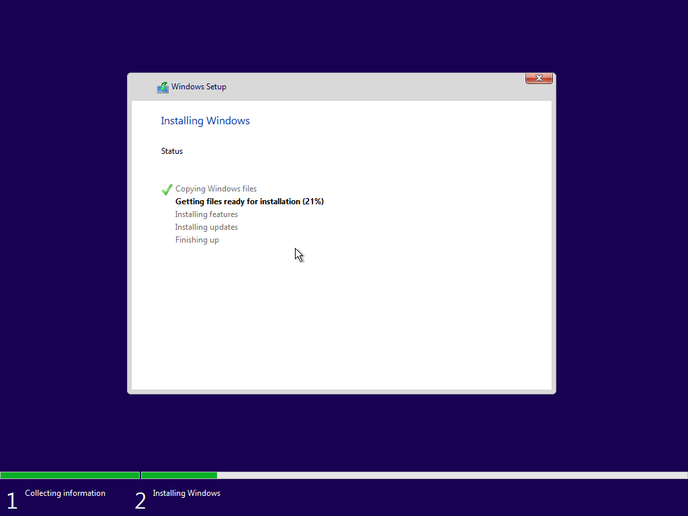

At this point, Windows starts to install the necessary components and data on the selected partition. It shows the status of the installation as well as useful information about the ongoing procedure.



Windows will launch following the completion of the installation. During this time, it is necessary to be patient and wait for a moment while the system boots up.

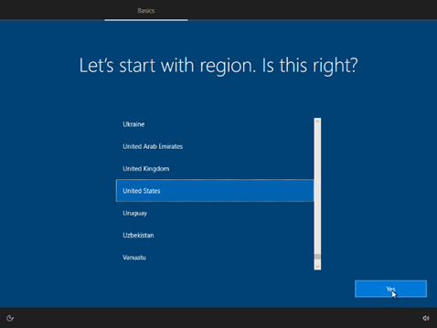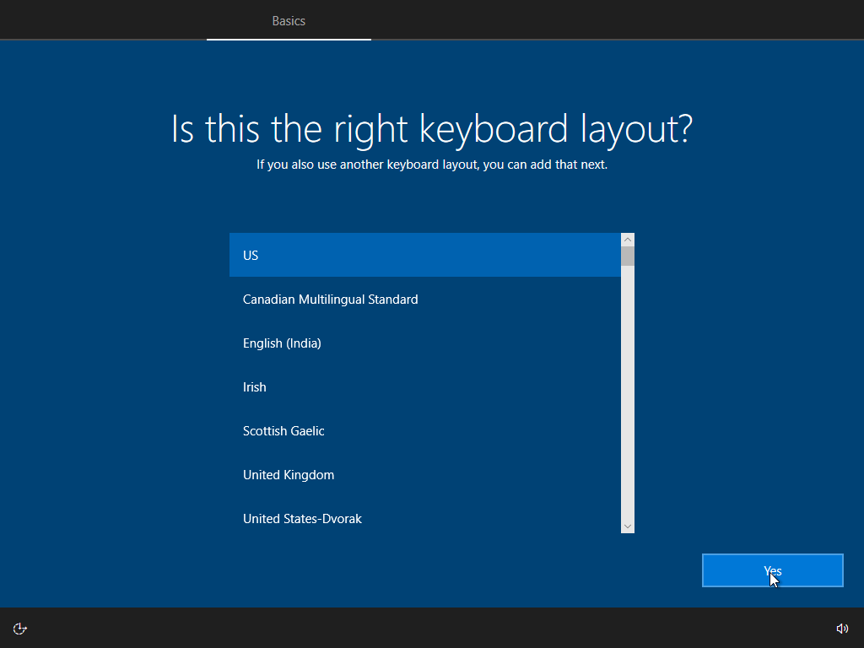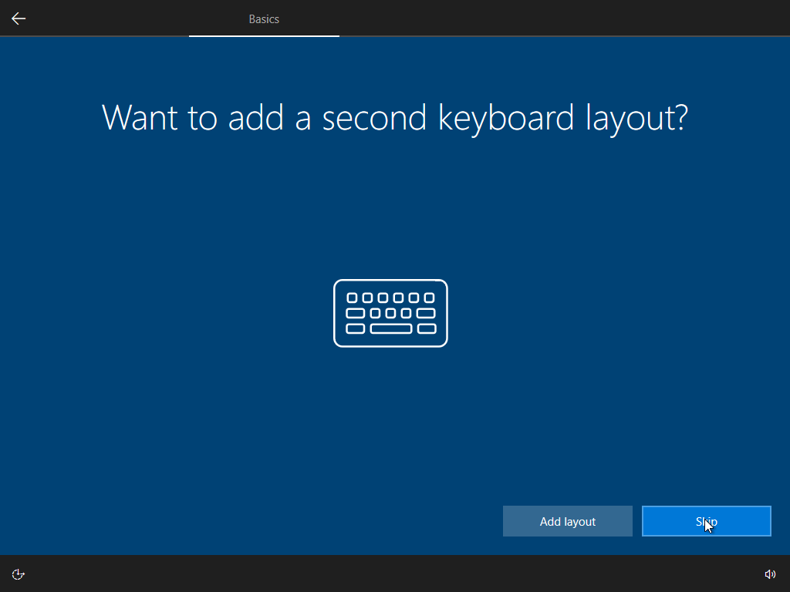

At this step, it prompted users to provide the second keyboard layout, the geographical location, and the keyboard layout. You have the option to install other keyboard layouts, which you can easily switch between while using Windows by pressing the WIN + Shift key combination. Click "Yes" to go to the next step.

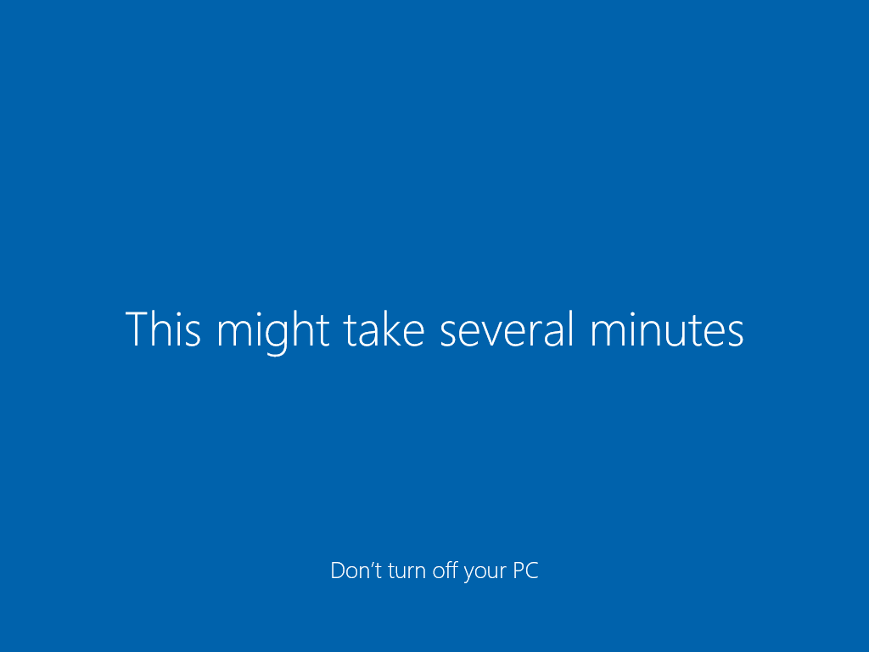

It is necessary to exercise patience and wait momentarily during the period.

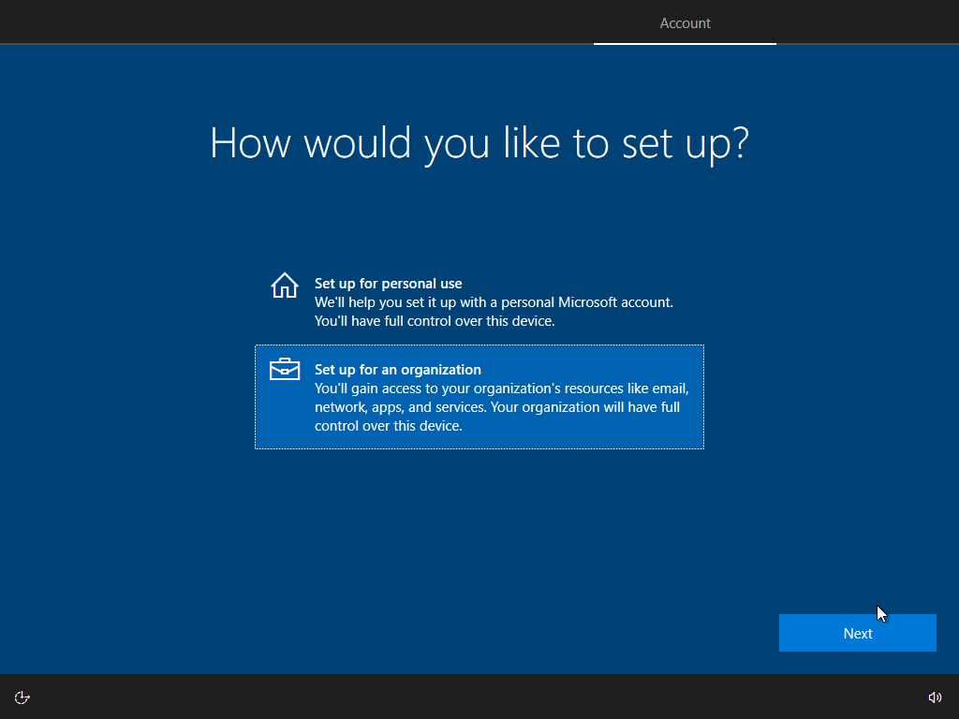

Selecting between an organizational or personal preconfigured setup is now necessary. We'll decide to set up for an Organization for this Windows. When done, click the "Next" button.

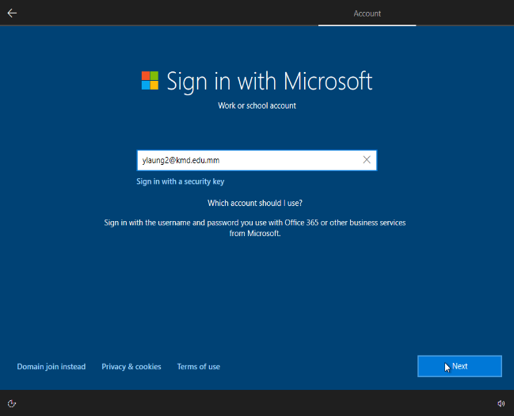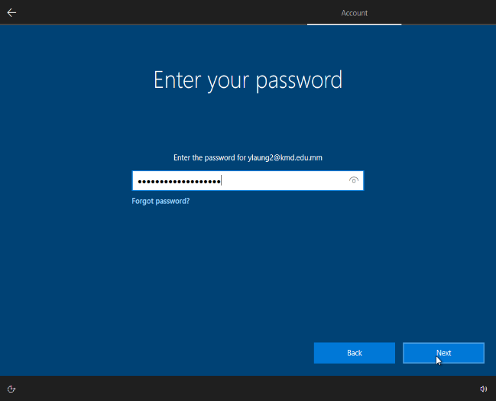

Proceed by signing in with my Microsoft school account and click on the “Next” button.

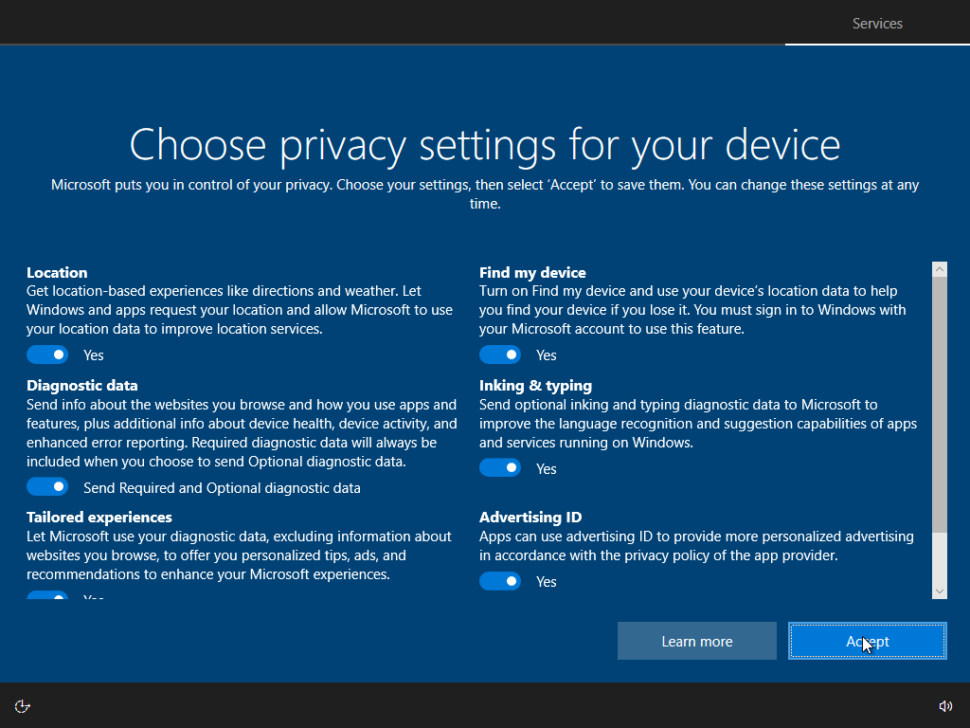

We are able to modify privacy settings according to personal preferences. Make no modifications during this phase and click "Accept."



Likewise, it's critical to exercise patience and wait a short while throughout this process.

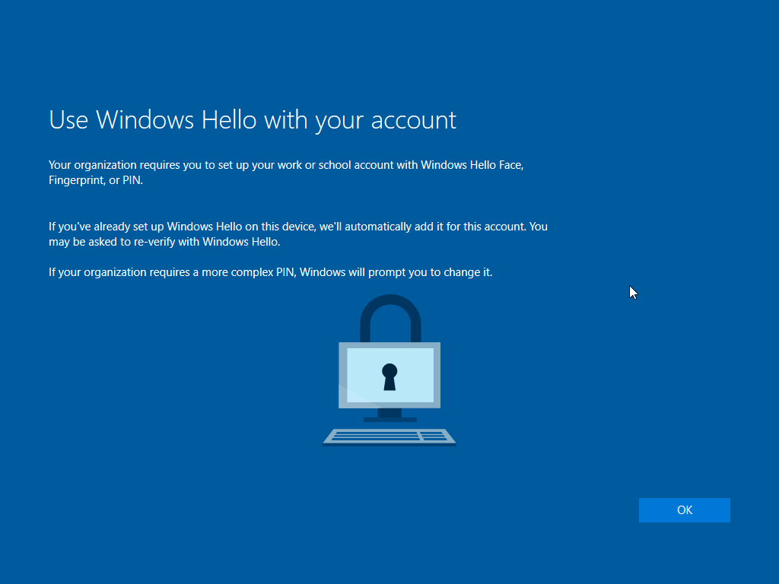

Windows 10 and Windows 11 biometric authentication features can be accessed by using Windows Hello in combination with a Microsoft account. This functionality enables users to employ facial recognition, fingerprint, or iris scanning methods to log in to their computer. People can benefit from enhanced security and simplicity of use by connecting Windows Hello to their Microsoft accounts. Just click the "OK" button to proceed to the next step.

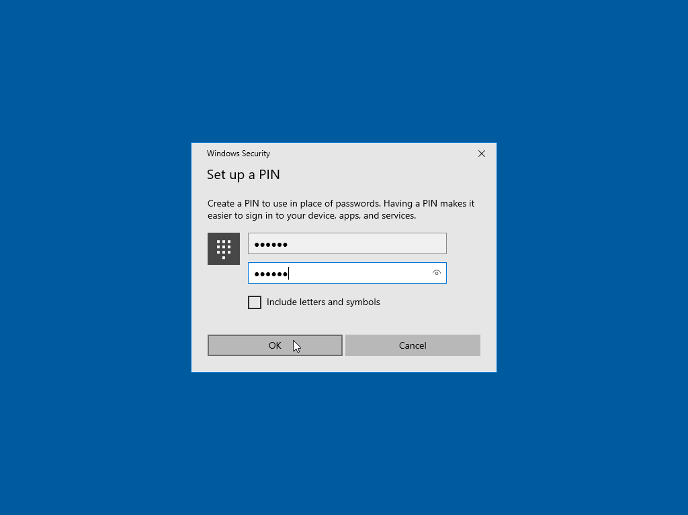

For Windows Security, we need to create a PIN to use in place of passwords. PIN must be at least 6 characters long. After that click the “OK” button.

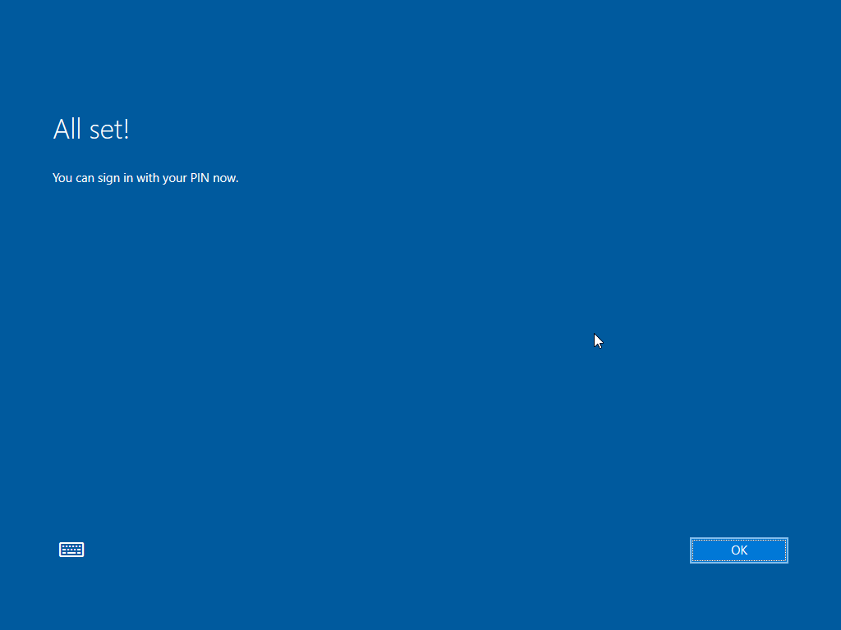

Now that everything is prepared, click "OK" to sign in using the PIN.

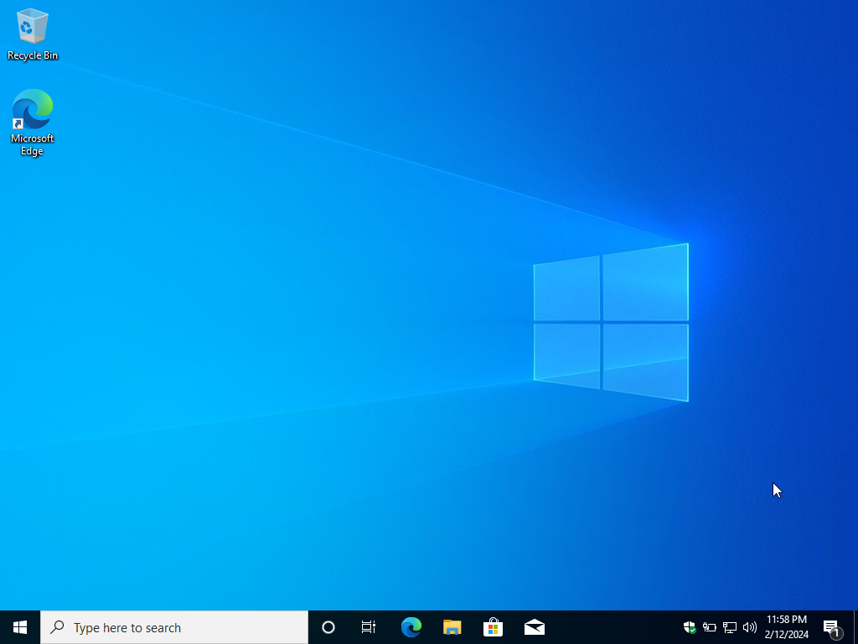

Finally, the familiar Windows 10 desktop can be greeted for the first time. This shows that Windows 10 Pro has been installed on my new computer and that the installation procedure has been completed successfully.

**2 . Description of drivers**

Maintaining a reliable and secure computing environment, optimizing performance, ensuring compatibility with current applications, and utilizing new features and advancements offered by hardware manufacturers all depend on having drivers that are up to date.

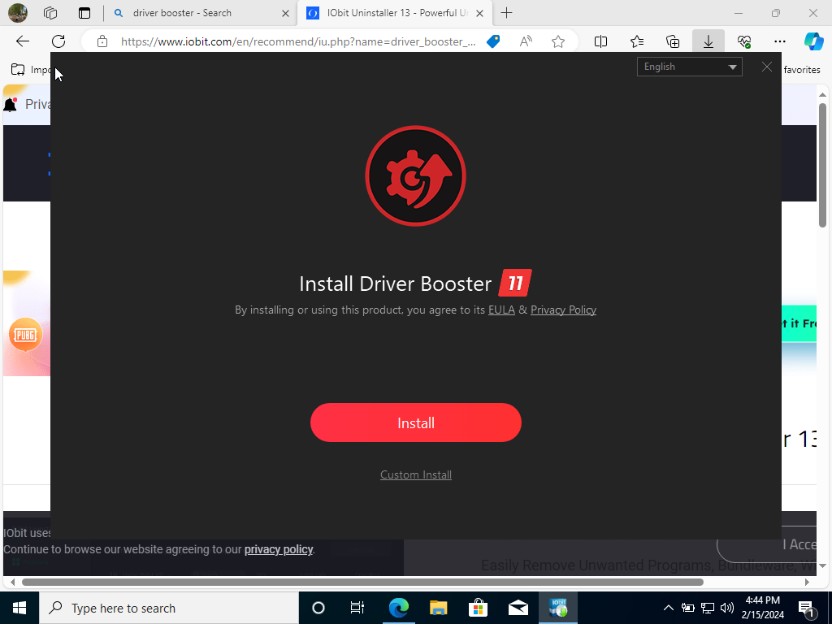

We are going to utilize an application called Driver Booster 11 to update drivers on Windows 10 Pro. Just click the “Free Download” option after clicking on the provided URL (<https://www.iobit.com/en/driver-booster.php>) to begin the program installation process.

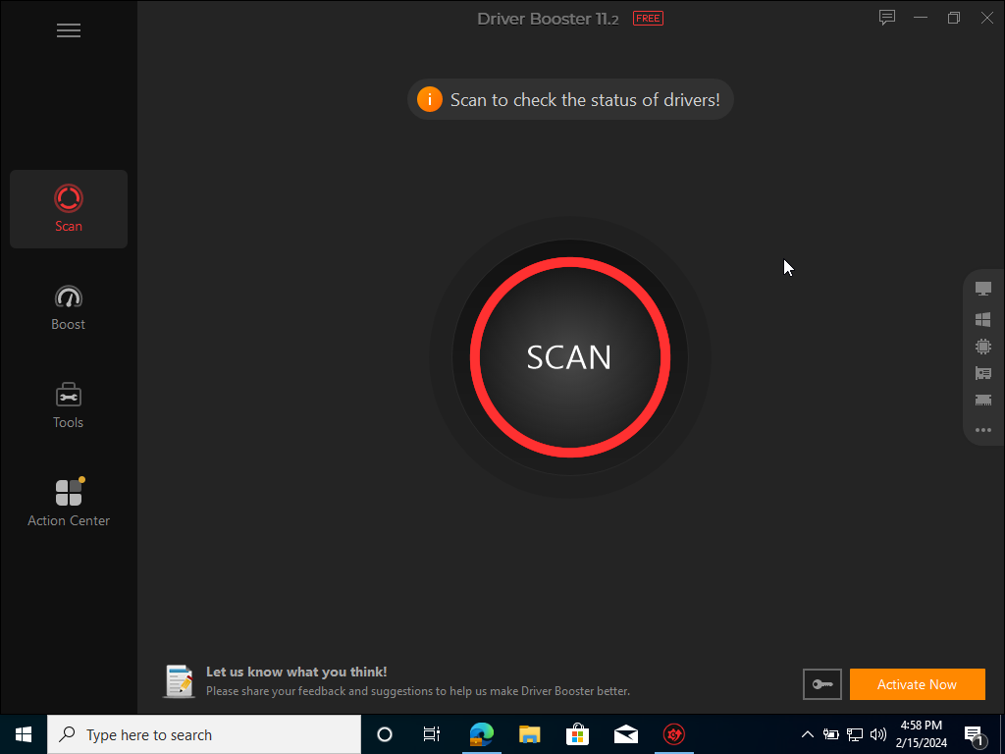

Following Driver Booster installation, the noticeable Scan button will be seen. We may check the status of drivers immediately by clicking on this button, which will start a scan.

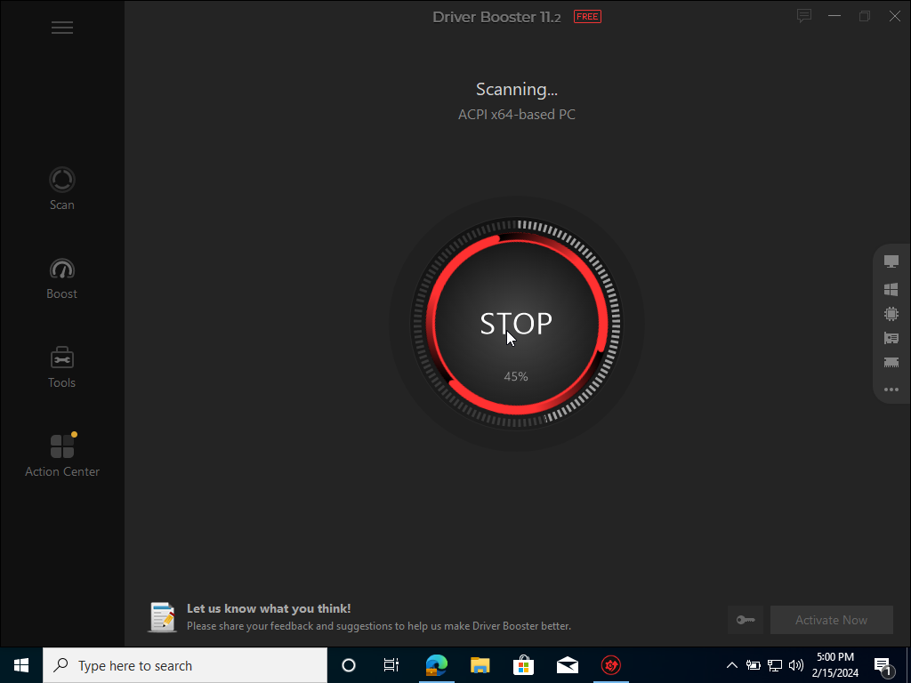

It is currently scanning. The scan can be stopped by clicking the Stop button.

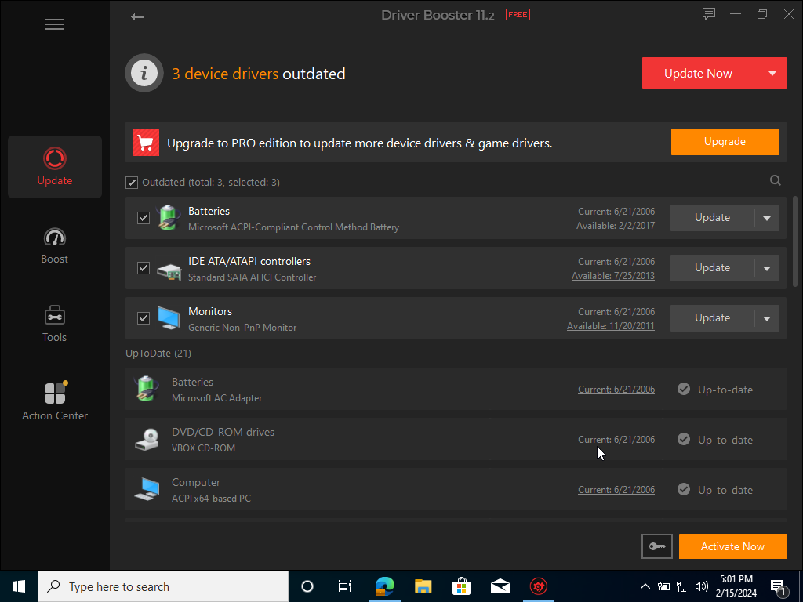

At the top of the scan results screen, we can see the total quantity of 3 outdated device drivers. Click the Update Now button.

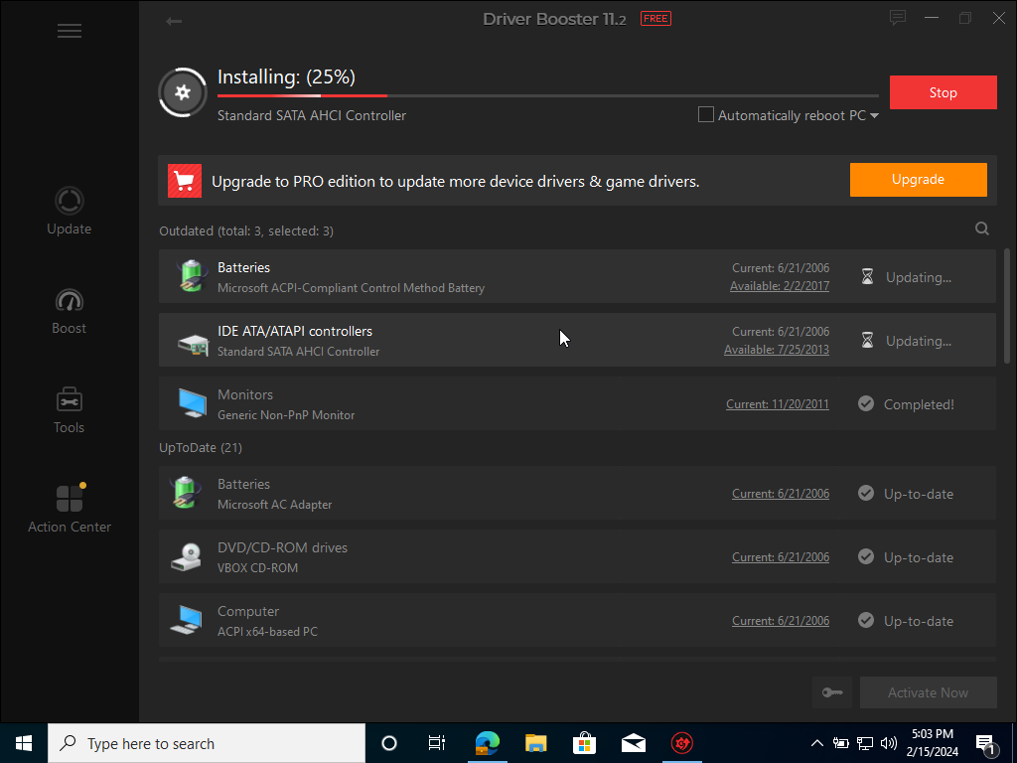

We have to wait for the downloading processes.

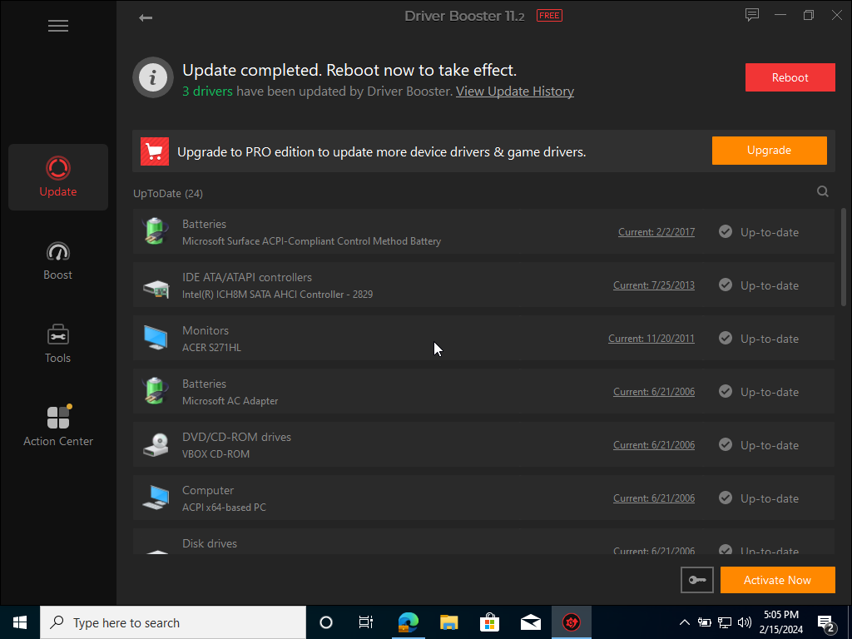

After the update processes are complete, click the Reboot button.



We have to wait a minute before the process is completed.

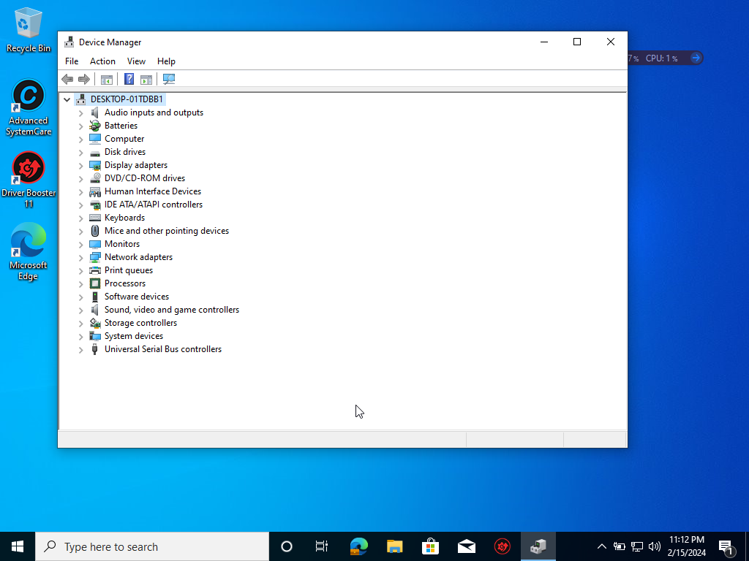

We discover that all drivers are now free of outdated issues when the device has restarted. This indicates that the most recent driver versions are currently installed on the device and that the driver updates were properly applied.

**3. Description of unsolved issues**

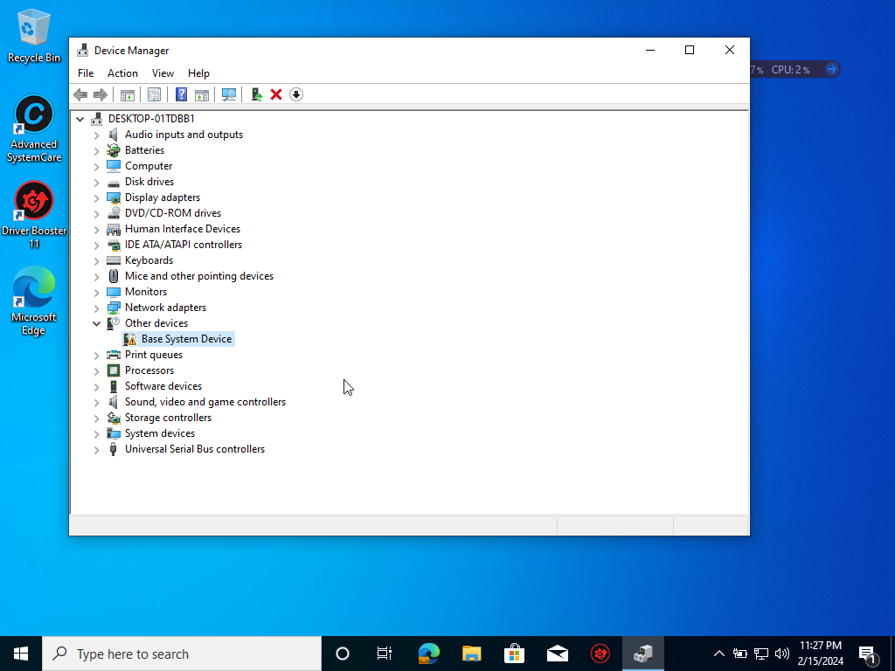

The base system driver is an unresolved issue in Windows 10 Pro. In Windows, a hardware component can be referred to as a "Base System Device" in a general sense. Examples of such components are the motherboard chipset, Bluetooth transmitters, and SD card readers. After installing Windows 10 Pro, the "Base System Device" error notice typically implies a driver that is either missing or was installed erroneously. When the operating system cannot identify or locate the correct driver for the device, this message appears in Device Manager.

**b) Installation of Antivirus Software**

**1. Identification of product used**

Avast antivirus software is a well-liked and efficient defense against threats. Its real-time scanning, virus detection, browser protection, and email scanning functions all work together to secure users’ PCs and sensitive data. Its feature integration makes this software highly rated.



**2. Identification and description of key stages in installation**

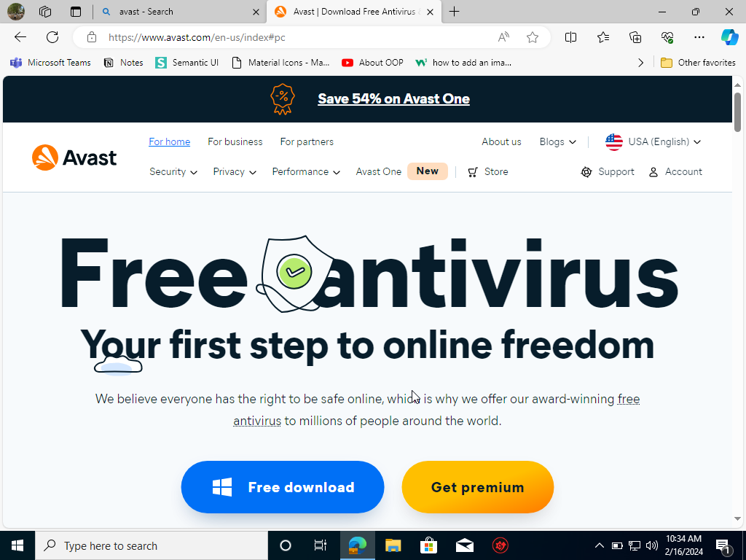

Look it up on Microsoft to install Avast Antivirus Software. This is the official Avast website link (<https://www.avast.com/en-us/index#pc>). Click the Free download button.

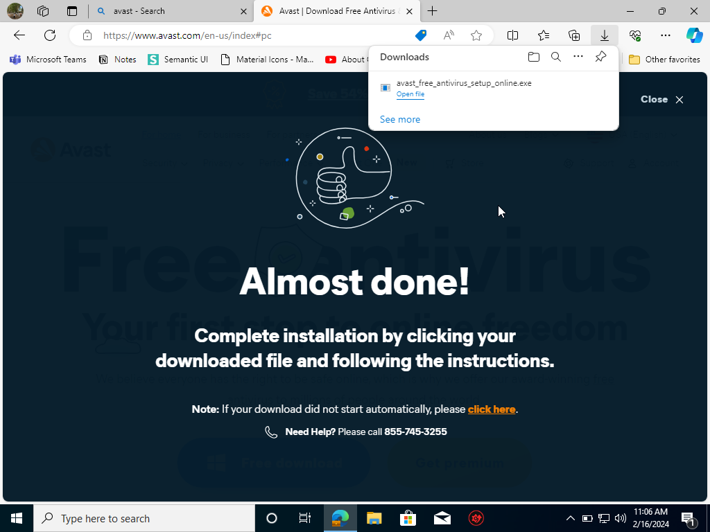

The Avast Antivirus Software will initiate the download automatically upon clicking the button.

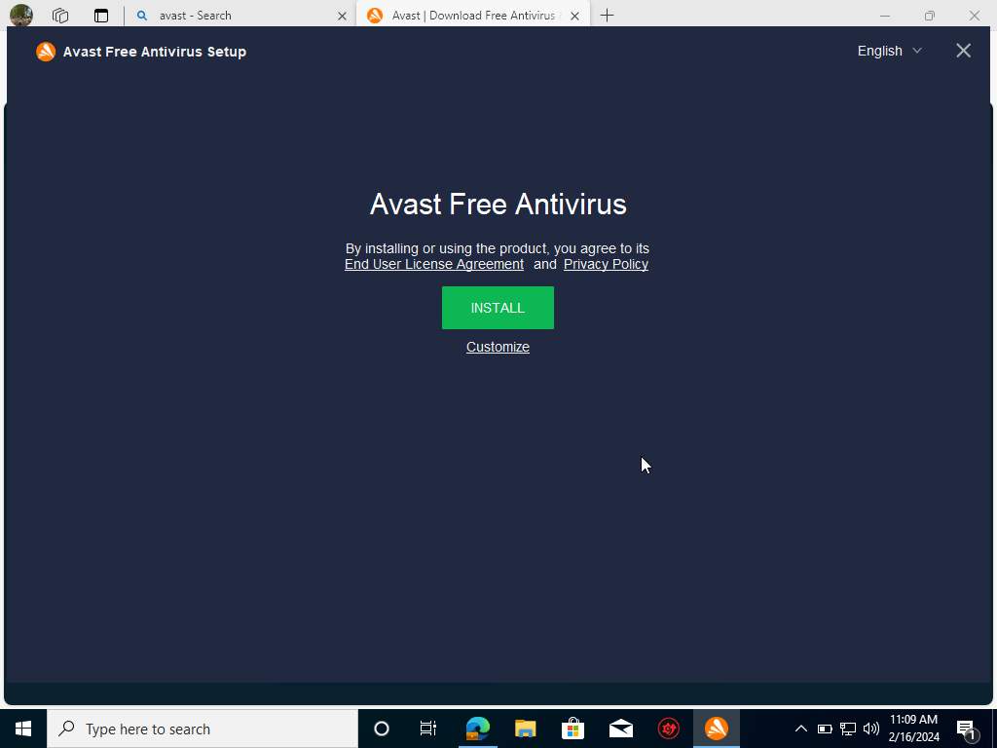

Click the Install button to install Avast Free Antivirus.

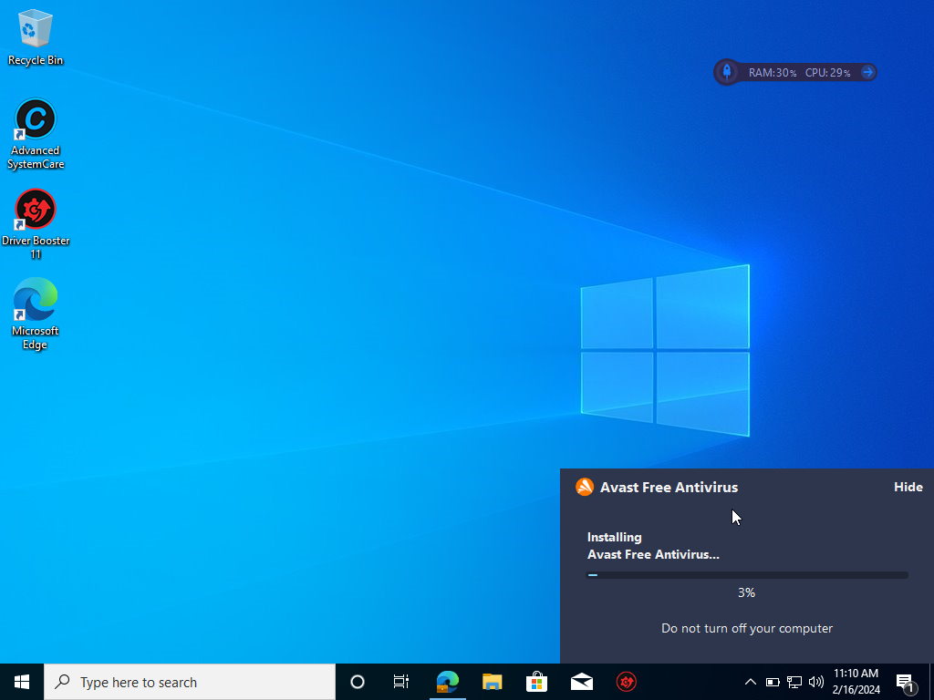

The Avast Free Antivirus Software is being installed.

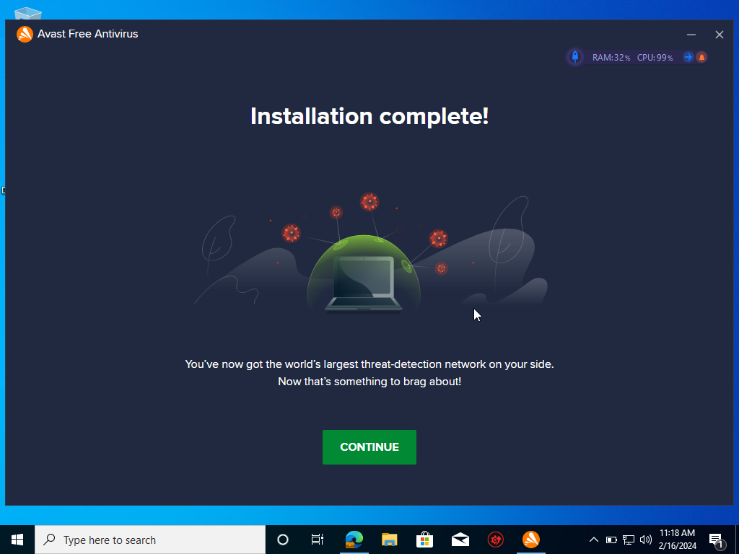

After the installation is finished, click the CONTINUE button to start the computer’s virus scan.

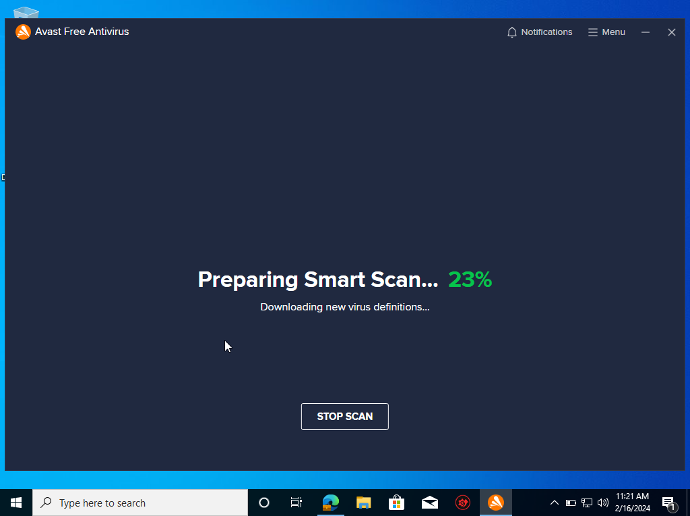

The scanning procedure is underway and includes looking at advanced issues, malware, viruses, and possible threats.

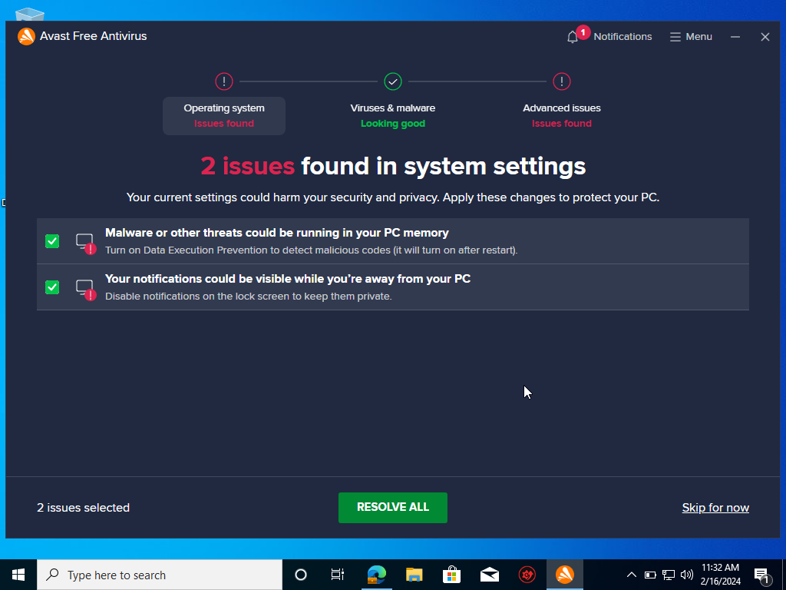

After the scanning is finished, an operating system and an advanced issue were detected. To resolve this issue, Avast recommends purchasing their Avast Premium Security. But click “Skip for now” for the time being.

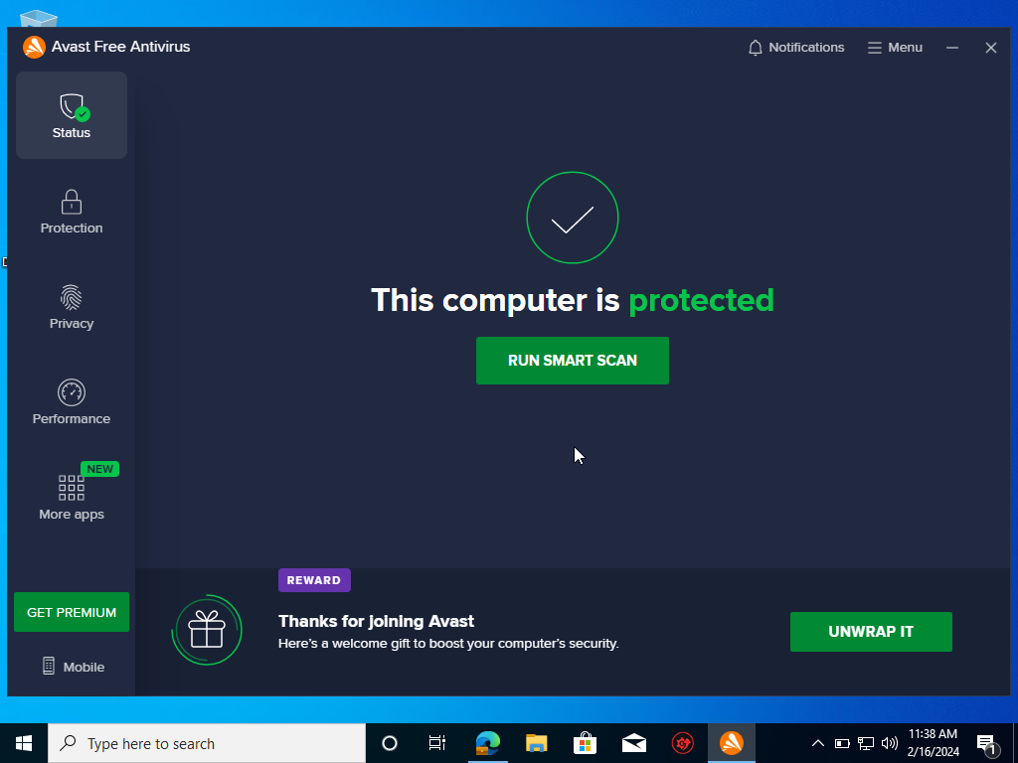

The Smart Scan has been finished, and the computer is now protected.

**3. Identification and description of problems and unresolved issues**

**4. Outline of the update process for the antivirus software**

These days, computer viruses are getting increasingly widespread. Antivirus software needs to be updated frequently because fraudsters are always coming up with new, complex attack methods. The antivirus program has been upgraded, and it can identify and eliminate new threats using the most recent defensive techniques.

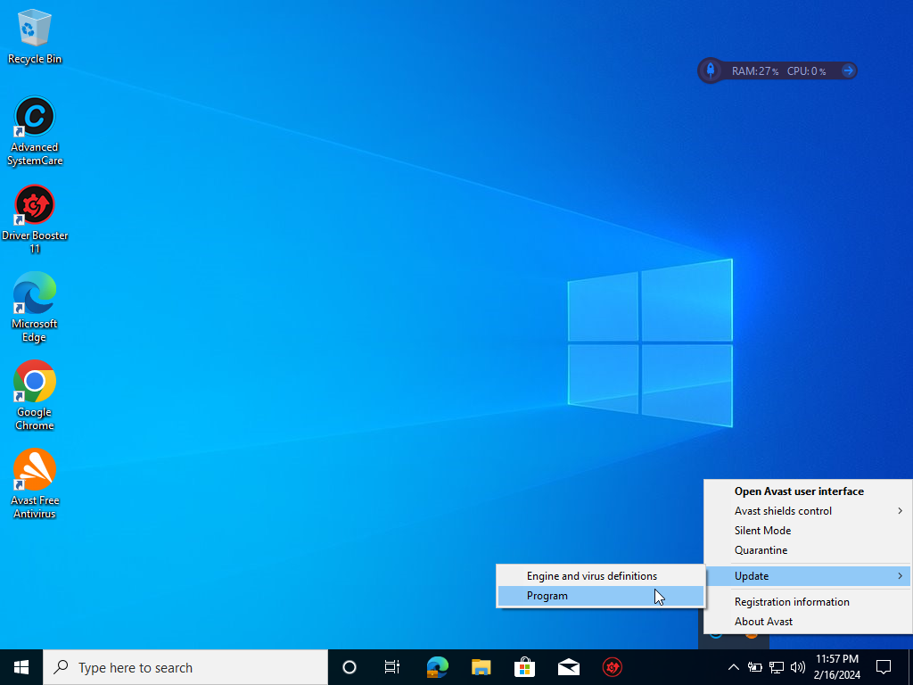

Find the hidden icons on the taskbar of the computer and right-click on the Avast logo to update Avast Antivirus. Click “Update”. After that, select “Program” from the update options.

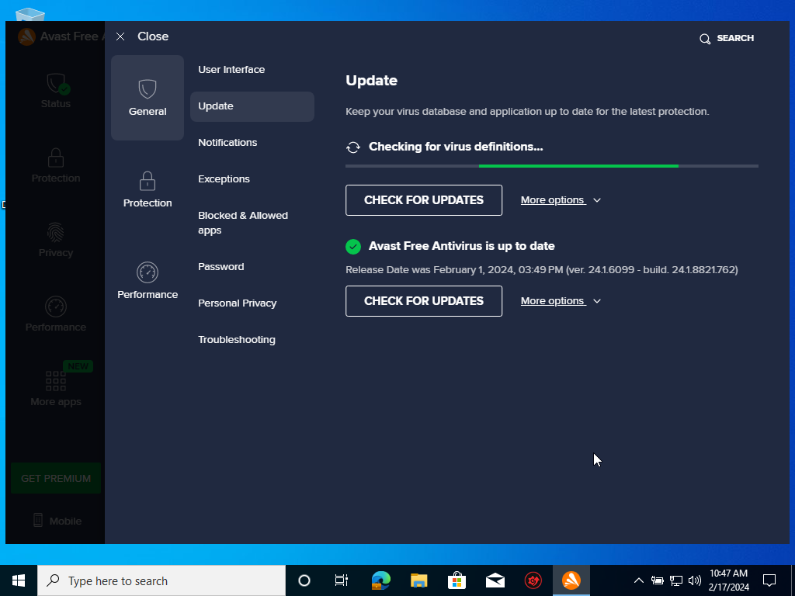

During the update process, it will check for both virus definitions and application updates.

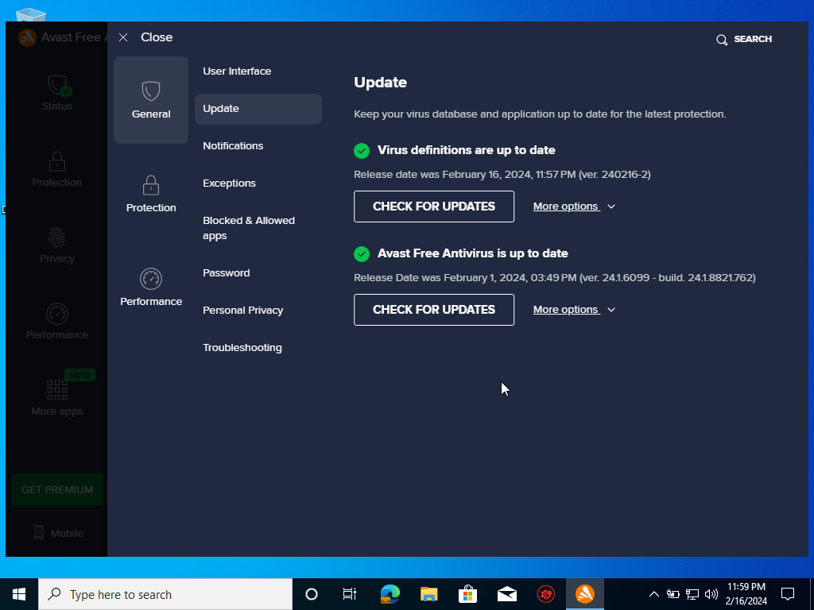

The antivirus software is now updated to the latest version.

**c) Installation of office software**

**1. Identification of product used**

